A Dying Art
The Permanently Dying Art of Poetry
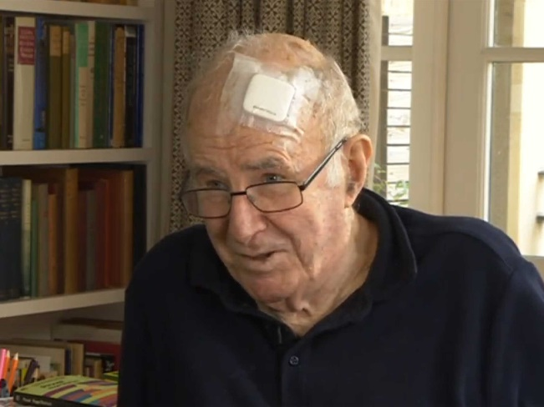
My new book of poems Sentenced to Life has just come out and is doing quite well, as publishers say about any book that will not send them bankrupt. By “doing quite well” they mean that actual live members of the public are actually buying it, using actual money.

It sounds like an unremarkable expectation, but the history of publishing is replete with examples of poetry books that sold no better than ice lollies in the Antarctic. Even the great W.H. Auden’s first collection took about a decade to sell out its first printing. For a poetry book to click, it helps if the author’s personal story has a point of news interest, and mine is the prospect of my imminent death.

Owing to the constant advances in medical science, my death turns out not to be quite as imminent all that, but one of the few advantages of the 24-hour news cycle is that the same media personnel who would otherwise be covering the outbreak of nuclear war will turn up to cover the drama of a cat trapped on a balcony. Will the fire brigade arrive in time?

I should try not to sound cynical about this or else every poet in the business will be trying it. Besides, there is the matter – crucially important in all branches of commerce – of whether the product is any good. If it is, then word gets around before the launch date. I would like to think that this is what has happened, but I could be fooling myself. Perhaps the sole virtue of my book is that its constituent poems have the same attraction as a man playing a piano at the edge of a tall cliff.

It wouldn’t matter if he played Chopin or “Chopsticks”: there would still be a crowd down there on the beach, standing back a bit so as not to get hit by a falling concert grand. But to be realistic, as opposed to tactically self-deprecating, the poems in this book are the best I have ever done. Television and radio interviewers assure me of that, as if they had been following my literary career since the beginning.

If only they had. There was a time when I could feel my literary reputation getting a bit lonely, especially when I was earning my bread by charging around a television studio, or indeed around the planet. But the pay for knocking myself out was pretty good. Not mad money, you understand, but still too good to complain about. For a poet, though, it’s not the dough that counts: it’s the attention. Deprived of that, even the oldest poet feels like Thomas Chatterton, who, while out walking through a churchyard back there in the 18thCentury, fell into an open grave, and later told a friend that he had been “at war with the grave” all his life. He was dead at the age of 18, having convinced everyone with taste that he was uniquely promising. Well, at least he got that much.

For the perennial breed of poets, to be neglected is an occupational hazard. Most of us deserve it. Nobody says most plumbers deserve it, but plumbers have to deliver. It doesn’t really matter whether a poet delivers or not. If poets don’t come through with the goods, nobody will be affected except them. It won’t be a case of the ruptured boiler flooding the parlour. It will just be a case of nothing much at all.

But that’s the very attraction that has drawn so many men – and, increasingly, otherwise sensible women – into a crazy game of hazard with almost nothing at stake. Because they have all guessed the truth: that the thing must be it own reward.

People will always ask what poetry is for. Sometimes I still ask that same question myself, after I have been up half the night slaving at as reluctant stanza when I have just had a haematology clinic the previous day and will have a pulmonary clinic tomorrow. Addenbrooke’s hospital is practically my hotel: 5-star accommodation with quite passable sandwiches. Why the hell do I still care about counting my syllables and about the hopeless paucity of rhymes for the word “death”? (“Breath” and “Macbeth” and that’s about it.) But after sixty years of it I care more than ever.

The sad and glorious truth is that we can’t choose to be poets. Poetry must choose us. A poem has a will of its own, and wants to get into us and grow, like a germ. I speak as someone who has met quite a lot of germs lately, and very few of them have anything but destruction in mind: but the poetic germ wants to create. What is it for? It is for itself, and for what it might become.

Poetry is the queen of the humanities because all the humanities must be done for themselves alone, but poetry can prove that this is so. Picasso finally died under such a mountain of money that from certain angles he looked like John D. Rockefeller. Picasso would have painted for nothing, but such is the nature of the art market that the day came when he couldn’t prove it. A poet can prove it. T.S. Eliot made a fortune as the lyricist of Cats but he made it after he died: while he lived, he needed his job almost to the end. A rich poet like James Merrill was born rich; and my own opinion of his poems is that a lot of them might have been even better if he’d had to compete in the open market, for the same peanuts as the rest of us.

But even if they compete successfully, poets don’t print their own money. I’m a bit strident on this subject because sometimes I have had to take a flatteringly admiring young aspirant aside and tell him that if he isn’t ready to die broke he shouldn’t even contemplate this caper. Even for Seamus Heaney, international success as a poet had to be supplemented by teaching. The Nobel Prize arrived after several decades of watching the pennies with care, aided by a wise wife of the rare kind occasionally sent from heaven to keep a poet’s nuts out of the fire.

If only the same had been true for Dylan Thomas: as things were, he was the author of the plangent phrase “lack of money continues to pour in”. The poet’s normal condition is to settle for all the rewards that are not financial and then not get even those. At best, there is a sprit of sacrificial romance, as there was for the Cavalier poets whose privilege, sword in hand and plumed hat gaily cast aside, was to be trampled flat by Cromwell’s dragoons. But usually there is nothing else to be gained, except, at the most, a pinch of immortality.

And yes, most poets have to live without that too. Any poet, no matter how much of a success he or she is – or, to put it realistically, no matter how much of a failure he or she isn’t – will sooner or later get the idea that the sales resistance to poetry is automatic and universal. People don’t really want it, because if it’s bad it bores them and if it’s good it hurts. People come reeling and sobbing out of a performance of Romeo and Juliet; they quote the balcony scene with trembling lips; and you can lead them to no more poetry except at gunpoint. They have been faced with the abyss, and it has happened too soon in their lives. There could be a connection: because, as I have recently found, to be really faced with the abyss means that poetry comes into the mind all the time, as if darkness could speak. Perhaps that’s what poetry is for: to help us die.

But surely it can also help us live. Though it has no use, it is life-enhancing because it doesn’t. It might help the Western world to survive the delusion that illiteracy equals authenticity, but that would be only a side-effect of its true purpose, which is to reveal the divine nature of the language in which it is written. Its mere existence proves that there can be patterns in the chaos. Hence the delighted sorrow when old people share a remembered phrase. And early on in their lives, before they have learned to be afraid, young people love the stuff. You can’t stop them chanting verse as they scoot around.

An adult poet is someone who can live to be a hundred and never leave the playground. But there are adult readers who also keep that young receptivity for verbal joy, and the hope of any poet is to reach them. If this book reaches them, I’m in luck. In luck again. The week before last my leukaemia came back out of remission, but there’s a new drug all set to fight it. The drug is called Ibrutinib. Can you beat that? It’s poetry.

--- Sunday Times, April 26, 2015

