Les Murray’s New Shed
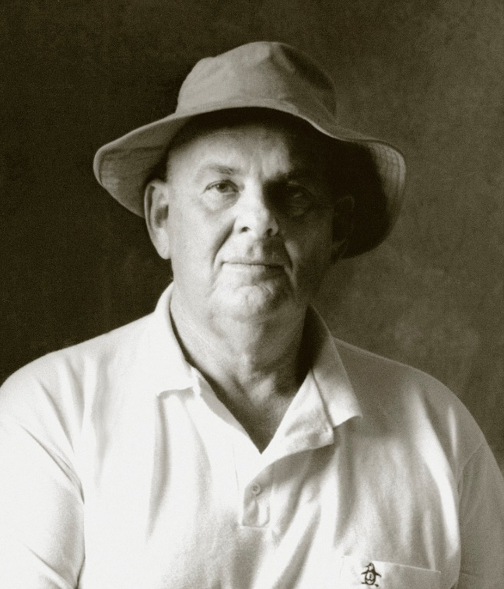
In the majesty of his years and accomplishments, Les Murray, sole author of the several increasingly massive editions of his New Collected Poems – one of the great books of the modern world – is in the position of a monarch who, having successfully constructed Versailles all on his own, is now pottering in the grounds building sheds. Six years ago The Biplane Houses was such a shed, and very prettily done. Now Taller When Prone is another. Perhaps I would not have had the idea of an enormous building and its satellite bâtiments if the first poem in the new book had not been about the Taj Mahal. The poem, called “From a Tourist Journal” starts like this.

In a precinct of liver stone, high
On its dais, the Taj seems bloc hail.

Immediately he’s got you in. He has always been able to do that. The way he can register, in words nobody else would quite choose, a perception nobody else could quite have, is at the centre of his art, ensuring almost infallibly that a poem will work like a lucky charm for as long as he pours in the images. A Taj made of hail: you and I might say that we would have seen that to be true eventually, and we might even argue learnedly that the word “Mahal” phonically suggested the word “hail” (points for an essay there), but the daunting truth is that he doesn’t just think that way, he sees that way.

Murray sees the things of this world mis à nu, like Baudelaire’s heart. (More points for an essay.) The charm is infinite because the universe goes on forever, and he would have something unique to say about every bit of it if he could go on sailing long enough through its eternity of transparencies. That’s why, I’ve just decided, the Versailles analogy won’t quite do for the big book of poems. Versailles is as charmless as the Escorial. There is nothing delicious about it. The Hermitage in Petersburg is a better bet, because you always want to break off a bit of plaster moulding and taste the quality of eighteenth century Italian sugar dipped in Russian winter air.

Such world-girdling analogies, however, are invariably appropriate as to scope, even when they err in their field of resonance. No poet has ever travelled like this one, whether in reality or just in his mind. This poet will show up wherever a specific quality comes to light, whether made by God or made by man – who is made by God too, who was man-made.

Perfection as a factory making depth,
Pearl chimneys of the Taj Mahal.

When Shah Jahan built the Taj to express his grief, his religion was concentrated into love, and one could say the same of the boy from Bunyah. Australia might seem like an unlikely place for all the religions in the history of the world to be combined in a single literary expression, but what the hell, the man who split the atom came from New Zealand. Intelligence of this intensity doesn’t have a single home. It belongs anywhere – anywhere that the pearl chimneys spill their depth.

In my dreams I see the ideal poetry teacher, nearly always a woman, giving personal instruction to the ideal pupil, nearly always a girl (the boys stay so thick so long, do they not? Although some of them sharpen up later, in their tediously competitive way), and the teacher says: “With Les Murray, you have to get the speed. As soon as the first image strikes, the poem is always on its way to somewhere else. He never elaborates without covering distance, so you have to keep your skates on.” In “As Country Was Slow” the new high-speed road is seen through what would be our eyes if they had enough supporting electronic equipment.

Our new motorway
Is a cross-country fort
And we reinforcements
Speed between earthworks
Water-sumps and counterscarps,
Breaking out on side glimpses,
Flying the overpasses

But by the third stanza the viewpoint has switched to beneath the road, and animals are doing the viewing.

Wildlife crossings underneath
The superglued pavement
Are jeep size: beasts must see
Nature restart beyond

Galway Kinnell once put a poem’s point of view inside a cow’s head, from which it could see rocks going by below on an endless conveyor belt. I wonder if Murray ever saw that poem but I don’t wonder very hard. I have never caught him borrowing anything except a range of possibility, and any good poet will borrow one of those. They aren’t, after all, nailed down. For all I know, Murray got the idea for talking about life in the bush when he first noticed how Shakespeare talked about life in a hedgerow. It’s something an exemplar can provide: you can break through to subject matter that lay so close you didn’t notice.

At home everywhere, Murray doesn’t always tell you that the poem is not set in Australia, although sometimes the title tips you off that he has crossed the world. It seems a fair guess that “Midi” is set in France, unless there’s a town called Midi somewhere near Murwillumbah.

Muscles and torsos of cloud
Ascended over the mountains.
The fields looked like high speed
So new mown was the hay.

The men in the creative writing class spot the hay laid out like a comic-book illustrator’s speed lines, but it takes one of the women present to wonder aloud what a stilted word like “ascended” is doing there. My ideal teacher raises the possibility that Murray is thinking of the ascending Christ in some of the last drawings of Michelangelo. She will remember, as we all must remember, that Murray has got a lot of artistic history in his head. He doesn’t have to dial it up. It goes with him.

Art, however, or let it be the knowledge of art, never clogs the basic work of perception, as unblunted with him as with an autistic child – burdened with family reasons for treating that subject, he is blessed with the ability to do so – or with a bat. (In one of my dreamings about Murray, a cave full of bats have a book club and study “Bats’ Ultrasound” on a continuous basis. This guy, they squeal, gets it.)

The bats see with sound. Murray sees so keenly that even his most attentive readers can forget he sometimes works a trick –or, to speak more grandly, points out a connection – with sound alone. In “Nursing Home” the clinching benediction of the last line comes purely through noise,

As bees summarise the garden.

You could call such an effect a nucleus in Murray’s total atomic effort. He starts small. But the speed of expansion can spread sonic precision to a whole topic. In “Eucalyptus for Exile”, the dangerously combustible propensities of Australia’s most globally popular tree are all there in a single word, “craquelure”. You don’t even have to look it up: just savour it, while wondering whether it was ever really a good idea to restore the English garden around your house to its native state.

Standing around among shed limbs
And loose craquelure of bark
Is home-country stuff
But fire is ingrained.
They explode the mansions of Malibu
Because to be eucalypts
They have to shower sometimes in Hell.

A lecture about Murray’s politics could start with that stanza. He is too much of a man of the bush ever to favour a Green ideology. In one of the many classic moments of his earlier poetry, the felled tree that dropped along its own shadow was earning a living for the loggers. Like almost all agrarian writers, Murray retains an element of conservatism that no amount of bien pensant gush from his readers can ever wish away. (Too long to quote here, and needing to be quoted in it entirety, “The 41st Year of 1968” is a sharp rebuke to ageing hippies who imagine themselves to be in sympathy with Gaia.)

Mainly the steady show of recalcitrant realism – not the purpose of his total effort, but nearly always its undertone – springs from the fact that the poet, like all the people mentioned in his poems, works for a living. Luckily for his box office figures, he doesn’t make the business of observation sound always like hard yakka. Even when close to home in the bush, you can sometimes, as in “The Cowladder Stanzas”, just look.

Not from a weather direction
Black cockatoos come crying over
Unflapping as Bleriot monoplanes
To crash in pine tops for the cones.

The monoplanes were in at the start of the transportation revolution that would give the Australian poets the world for an oyster. Famous for having never left home, Murray has left home over and over, piling up the languages and the air-miles in a quietly successful quest for world citizenship. He might not have any money in Switzerland, but during the long flight he knows which leg to sleep on when “Visiting Geneva”.

I arrived in spring when
The Ferraris came out.

Some day soon perhaps, a jet will take him to Stockholm. Only occasionally changing its personnel and never changing its dark suits, the Nobel Prize committee has seldom been a good judge of poetry, but once in a blue moon they get it right, and Murray’s world currency is hard to miss. The question of why this should be so is always worth asking. There are poets, even Australian poets, as universal in their scope and even more learned: Peter Porter is only one of them. But Murray’s international appeal works on the assumption that he speaks a lingua franca. The assumption is not quite so absurd as it might at first seem. When you get right down to it, he does. The perceptions and connections would show up in any language that could find the verbal equivalents.

The trick, from the Stockholm angle, lies in the translation. The translator needs not only to be a master of his own language, he needs to be terrific in English. One can imagine Murray’s Japanese translator consumed for a full year – the time needed to anneal the blade of a good sword – in finding the equivalent for that half line in “The Buladelah-Taree Holiday Song Cycle” when the ibises, having arrived at their place of work, get busy.

Pronging the earth, they make little socket noises.

But it could be done, because first and foremost so much of Murray’s inventive force is antecedent to language. Seeing the shape or hearing the sound of one thing in another, he finds forms. A world of forms is what Picasso inhabited, and when he started painting the pictures to prove it, he left the world of immediate charm. Murray has never done that, although lately he has shown signs. There are poems in this book that are hard to figure out, which isn’t like him.

For all his career, close reading has been rewarded with meaning. The implication that meaning might be beyond reach is rare for him, and really something new. Perhaps he’s getting ready to start again. Perhaps the Versailles-Hermitage was only a shed, and now he wants to build the real palace. There might not appear to be much time, but he wrote Fredy Neptune in no time at all. Nevertheless it’s hard to abandon the idea that one of the great merits of his outstanding body of achievement is its intelligibility. To make its first impact on the new reader, it doesn’t really need a preliminary lecture, or an essay, or even the ideal teacher. It just needs you, the visitor to the “Southern Hemisphere Gardens”, ready to wait patiently while the beauty comes welling up.

The nankeen heron has moved to Japan
But ink-blue waterhens preen long feet
Or, flashing undertail
Like feathers of the queen protea, run
Each other round the brimming rain dam
Where inner sky is black below shine
As if Space were closer, down.

Even before you look up “protea”, you know for sure where this is that he’s taken you. It’s heaven, for which Space is just another name, another word.

-- The Monthly, April 2010

