Ha Lo and the electric talker

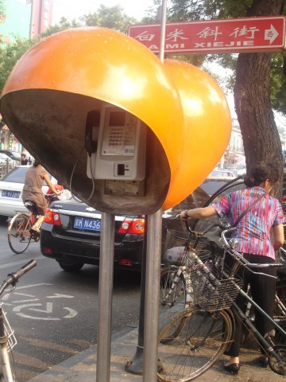
My morbid interest in the Philosophy and Technology of the Telephone continues. Did you see not long back that there is a man in the New Forest whose telephone rings every time he flushes the lavatory? I have the cutting filed somewhere under "Telephones, Nervous Disorders of." Though if it turns out to be also the case that the lavatory flushes every time the telephone rings, I may have to change the diagnosis. Flushing whenever the phone rings — I guess that's just love.
Anyway, no amateur of the telephone has time to be bored. The other day a team of cerebral looking men came down our road and made fine expert adjustments to the telephone cable, as a result of which the wire was disconnected from my telephone and connected to the telephone of an entirely different subscriber. Fastidious as ever, I complained about this, and the engineers reconnected me — adding, without extra charge, the wire formerly leading to the other subscriber's phone, so that I got all the calls for both of us.
I felt horribly mean when I complained about this generous arrangement. But the Post Office were most polite and helpful, and sent round another team of men who radically readjusted the whole system once again — so that I got all this other man's calls and he got all mine. It went on like this for three days. Oh, we all enjoyed it, really — though I have to be careful about my blood pressure now.
But the greatest step forward in telephone technology since Edison discovered the wrong number has just been made by the New York Telephone Company. They have installed in New York's Chinatown twelve Chinese telephone kiosks, with pagoda roofs, red, gold, and green paintwork, and signs saying "Gung Yung Deen Wah," which is said to mean "Public Use Electric Talker."
Chinese! Now there's a language that does justice to the telephone. Here's my rough translation into Mandarin of the instructions, or Public Read See What Do, that will go inside our own Public Use Electric Talker boxes when the GPO catch up on the idea. Will the GPO kindly make all royalties payable to the Emotionally Disabled Telephone Subscribers' Aid Fund?
To call electric talker sufferers on local electric talker suffering causing centres:
Insert four pennies. If no have four pennies, take silver dollar along nearest smoking tube merchant humbly beg change. Smoking tube merchant unhumbly reply no change given for electric talker. Go eventide news scroll merchant, buy unwanted eventide news scroll. Return with change to public use electric talker. Find member public electric talking. Go teahouse, seek solace heavenly tea. Return public use electric talker, find no man electric talking. Feel encouragement. Find have given heavenly teahouse all heavenly four pennies. Feel delicate Chinese melancholy. Return eventide news scroll merchant, buy still less wanted eventide news scroll.
Insert four pennies. Lift electric ear. Wait electric ear sing cicada song Prah-ah-ah-ah-ah. Place finger in nostril electric talker face. Savagely twist electric talker face back forth back forth until it talks. If no talk, shake electric earholder up down up down. If still no talk, punch nose electric talker, kick beat knock jab pummel. Offer profane invocation gods. Curse ancestor's electric talker. Talk self unelectric talk.
Electric alker sing song two bees — Hbuz, Hbuz Hbuz — melodiously continuing until eternity. Meaning: desired electric talker sufferer away on holiday. Feel sure electric talker purveying melodious falsehood. Twist ugly face again. Electric talker now sing song suffering dog — Hai-ai-ai-ai-ai. Meaning: desired electric talker sufferer bankrupt removed insane dead electric talk no more. Electric talker talking electric nonsense.
Freely apply Chinese torture electric talker face once more. Now talker talk. Talker say Ha Lo, Ha Lo, Ha Lo. Reply Ha Lo, Hoo Ah Mai Spee King Tu? Talker say Ha Lo, Ha Lo. Shout Hoo Ah Mai Spee King Tu? Talker say Ha Lo, Ha Lo, Ha Lo... Reply profane curses ashes father. Remember have not punched electric talker on belly button. Try this. Find profane curses now audible electric talker sufferer. Also find electric talker sufferer Ha Lo not electric talker sufferer desired.
Take silver dollar along eventide news scroll merchant buy another filthy eventide news scroll. Visit heavenly gin-palace brace nerves long intoxicating drink...

