Ars Longa, Screwe Stronga
Screwe (Twicestershire), Thursday
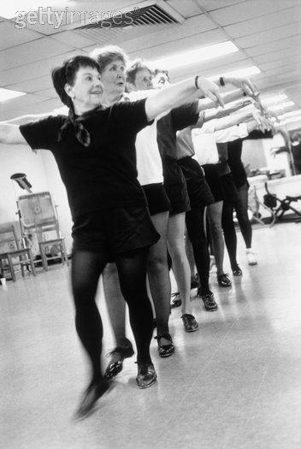
The Screwe Festival — the first swallow of the summer festival season — was opened here today by the Mayor, Alderman Sydney Spanner. At a ceremony outside the town hall, beneath the Screwe Corporation motto ("Plus ça change, plus c'est la même Screwe") Alderman Spanner unveiled a notice-board reading "Welcome to Screwe, an accident black spot."
"This festival," said Alderman Spanner, " is not only a disinterested contribution to the cultural heritage of West Twicestershire, but should also attract a profitable stream of tourists and increase our rateable values. It was brought into being in response to the unanimous wishes of all Scruvians, in spite of attempts to wreck it emanating from certain quarters which I shall not name. Alderman Thudge and others, I dare say, are not unaware of who the finger will be pointed at."
According to Mr. Rollo Swavely, the well-known public relations consultant (whose accounts include the Lard Marketing Board and the Carbohydrate Council, and who has been hired by the festival committee at a cost of a third of their total budget), both the Screwe Arms and the town's other leading hostelry, the White Star Temperance Hotel, are almost fully booked for the week.
The biggest attraction is likely to be the concert given tomorrow night by the Ohio Philharmonic Orchestra, under its conductor Wladislaw Czrynk, in the Arthur Tappet Memorial Hall. It will be an evening of intimate music, since, with a full orchestra taking up most of the hall, there will only be room for an audience of twenty.
There has been some controversy over the programme for the concert. One item was cancelled after a protest from Alderman Thudge, who got Screwe into the headlines some months ago by having Lady Windermere's Fan removed from the public library in the belief that it was a sequel to Lady Chatterley's Lover. Alderman Thudge described the item, "Night on the Bare Mountain," as an affront to public decency because it seemed to give tacit approval to nudity.
Mr. Czrynk proposed replacing it with "Nights in the Gardens of Spain," but Alderman Thudge said he felt this tide was even more suggestive. At the moment the only items agreed upon are the National Anthem, Percy Grinder's "Fantasia on Old English Streetcries," and the first performance of a new work by the local composer Herbert Harris, "Symphonic Suite: Screwe." The other chief musical offerings of the week will be a display of tap-dancing by the East Screwe Ladies' Guild on Monday, and on Wednesday a concert by the massed silver bands of Screwe Main Colliery, Screwe Church Lads' Brigade, and the local depot of the West Twicestershire Road Haulage Company.
Nor have the visual and dramatic arts been forgotten. This afternoon Mr. Algernon Froth, the noted bon vivant, will open an exhibition in the foyer of the Arthur Tappet Memorial Hall entitled "Some Trends in English Teaspoon Design, 1670 to the Present Day." The manager of the Screwe Hippodrome, which was to have presented a show called The Belles are Peeling, has announced that to help maintain the tone and spirit of the festival he will instead put on a Japanese Noh play. It will be called Yes, We Have Noh Pyjamas.
Those who enjoy the lighter side will perhaps prefer the massed searchlight tattoo which will be presented on the Rawalpindi Street children's playground by the local cadet corps, or a fringe production in the Gibraltar Street Assembly Rooms by the Oxford University Experimental Drama Unit called Screweballs of 1960.
"What I do feel most awfully strongly," said Mr. Swavely at a press conference in the American cocktail bar of the Screwe Arms this afternoon, motioning to the waiter for more double Scotches all round, "is that all of us here at Screwe are convinced we are making a most frightfully important contribution to something which is, today more than ever, terribly, terribly vital."
"That's right," said Alderman Spanner. "If we can get away with the Ohio Philharmonic Band this year, I'll wager my chain of office we can get away with film starlets bathing naked in the river next year."

