Ye Globe Theatre
As You Like It
PRESS RELEASE NO. 12
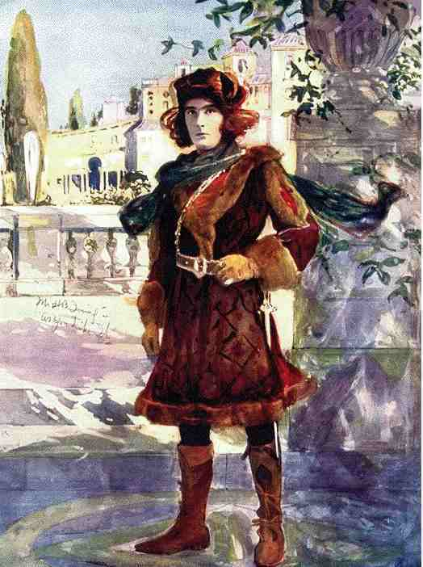
"Ye sauceyest piece since ye Decameron," saith controversiall producer Harold Baconburger. "Will Shakespeare's 'As You Like It' at ye Globe Theatre will stryke London yare and square between ye optick orbs."
Sire of four Baconburger is quietly impassion'd about his latest venture. He believeth he hath a mission to bring Art to ye People, and feeleth it reward enough that for "As You Like It" he hath ta'en ye most monstrous revenues prior to performance ever known. As they like it is as he liketh it!
"Ye play," he saith, "is ye storie of a man... and a woman ... alone together in ye forest. With searing franknesse and delicious naughtienesse it showeth love — as love was meant to bee! I believe every one ought to see this playe. And withal a million laughs for mewling infant and drooling dotard alike!"
EARL'S FRIEND WRITETH PLAYE
Bearded playwrighte Will Shakespeare hath writ so manye playes that he sweareth he can no longer recall in fine how manye! "I trow this must be my nineteenth or twentieth," he laught ye othere day, pouring sack from a silver sackbutt giv'n him by his olde friend ye Earl of Southampton.
"I am oft askt wherein lieth ye secrett of my success," went on Will, thirty?nine?yeare olde ex?grammar school boy from ye Midlands, whome commentators have dubbed ye success storie of ye age. "Welle, I believe there is a tyde in ye affayres of men, which, taken at ye floode, leads on to fortune, to coyne a phrase."
Will hath a reputation for gaie lyving, and his distinguished profyle is oft seen about at ye brightest of ye night spotts. He worketh presently upon a merry farce in which one whose wits are astray meeteth with a ghost walking ye ramparts, which sets an hilarious chayne of misunderstandings and disasters afoot! Harold Baconburger hopeth to have John Dowland wryte ye musick for 't, and open it with Richard Burbage in ye title role for ye Christmas season.
What is't like to be married to a successful playwrighte ? Quoth Will's wyfe, formerly lovely modell Anne Hathaway. "It meaneth having ye house cluttered up with lyttel bitts of paper, and ye carpet stayned with ink. Let me warn any young maid who thinketh to marry a playwrighte that it is not all glamorous first nights!"
ASS HE LIK'D IT NOT
"When I waxed hot in rehearsing my role as Orlando, ye frustrated hero who is a symboll of our tymes," recounteth Thomas Garbage, ye popular young actor who was voted Best?Cloakt Man of 1598, "I was mighty pleased to find a stage?hand cooling my heated brow by plashing it with water, as methought, and cryed for more. Imagine my cruell vexment, then, when I lookt up and saw it was not water but whytewashe! 'Ass!' I roar'd — which sallye ye fellow capt with 'You like it!' Faith, how we guffaw'd!"
COULD HAVE DYED WHEN THEY TOLD HIM
"My poor head whirleth! " laugheth fourteen?summers?olde Hal Trucklebarrow, who playeth Rosalind, a Duke's daughter head-over?heeles in love. "I am full used to playing women, of course, but forsooth, when they told mee I was to play a woman drest as a man acting ye part of a woman, i' faith, I could have dyed!" Addeth Hal — a funn?loving good?looker whose ambition is to get to ye topp as a lute?player, "I know not what my steady mistress will saye when she hears about this!"
Hurricanoes of mirthe interrupted rehearsals at ye Globe when well-cognised funster Norman Nolledge, who playeth Touchstone, a loveable countrie bumpkin, slipt on an abandon'd Simnel cake and fell pate-foremost into a cleaner's bucket. "When I arose, pate and pail were fast," reminisceth Norman ruefully. "Everyone did think I jested, as is my wont, but by my faith 'twas no jest! I had to bee bled for three dayes before my head did shrink enough to doff ye importunate headpiece!" When ye playe openeth next week, Norman will be cupped in ye wings betwixt houses, and bee able to appear at all onlie in greate agonie and with leeches clapt on beneath his undershirt.

