The Literature of Coexistentialism
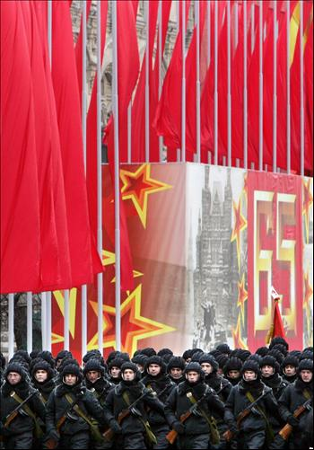
The last time I was in Moscow an article I wrote for the Guardian describing my impressions of that city called forth half a column of the most envenomed and personal abuse in Izvestia. So I was delighted to find this week a model of the sort of article I should have written — a piece by Mr. Alexei Adzhubei, the editor-in-chief of Izvestia, on his impressions of London.
The article was written at the request of the Sunday Express, after Mr. Adzhubei had visited Britain for the unofficial talks at Wiston House (and incidentally offered to take over the editorial chair of the Daily Mail and double the paper's readership in two months). When the Sunday Express saw the finished product, however, they turned it down, on the ground that it did not "quite measure up to the standard of interest and entertainment that we aim to provide."
It was rescued from the waste-paper basket by the Sunday Pictorial, who published it together with a reproach for the "puny and frivolous" attitude of the Sunday Express towards the problem of understanding the Russians.
Just how considerable this problem is you can discover for yourself by reading Mr. Adzhubei's article. I will make my little contribution to solving it by admitting that by Mr. Adzhubei standards my piece on Moscow was simply not up to scratch. Humbly confessing my past errors, I present it again, entirely rewritten in the Adzhubei peaceful coexistence style. Izvestia may reprint it if they want to, but if it doesn't quite measure up to their standard of interest and entertainment I'll submit it of the "What I did in my holidays" competition inChicks' Own.
MOSCOW
Moscow is an interesting city. I am happy to have the opportunity of describing my impressions of it. Perhaps this is because it is such an interesting city. Or perhaps there is some other explanation.
I will be as brief as possible. I must say first that we in England have already heard of your city. It is, in my opinion, a big city. There are many buildings and streets in it. I do not want to trespass on your countrymen's most intimate national feelings, but as I walked around the streets I could not help thinking "This is a big city, and an interesting one."
In a short article like this there is not enough space to list all the sights I saw. But I must mention the Kremlin, an old building which I find most interesting. I also saw Red Square and the Bolshoi Theatre. I don't have to tell you that, by and large, and on the whole, they are impressive and interesting. There were also many other sights of historical interest I saw in Moscow. I have no space to mention them all, but as I looked at them I was most strongly impressed by how interesting they were. Need I add that some were also big?
While I was in Moscow I heard Russian spoken. It was being spoken by Russians, quite fluently. To all you Russians, whether in Moscow, Leningrad, Kiev, or Odessa, I bring greetings from the people of London, Manchester, Birmingham, and Bury St. Edmunds. I talked to some of you about subjects too numerous to mention here. We did not attempt to listen to one another. Everyone must decide for himself how to live, without listening to anyone else.
Unless the editor has any objection, I should like to give some more of my impressions of Moscow, although of course space is too limited to mention more than a few. I saw cars and buses in the streets. I saw trains going along by the ingenious use of wheels running on rails. All this is the Moscow one does not read about in guide books. I find it very interesting.
Very soon now there won't be any more space left at all before the end of the article. I should like to use what there is to say that even if there were more space left, which there is not, I rather doubt if I could have given a better impression of your big and interesting town. To sum up, I saw the Kremlin, Red Square, the Bolshoi Theatre, and many other historical monuments which lack of space prevents me mentioning by name. On this note I must conclude my article, which I am writing on paper, sitting at a table.

